**Programming Challenges #3 – Due on or before midnight Friday 5/10**

**Objective:** Single Dimensional Arrays

|  |
| --- |
| **Important instructions:**   * *All programs must include comments at the top of your program: your name, course name- CSIT 575, program name and the program description in brief.* * *Copy and paste your program code and outputs in Part B of each program.* * *Once it is done, save and submit this word file via Canvas.* |

**FindLargestSmallesIndex.cpp**

Write a program that randomly displays 15 integers in a range from 0-20. The program will find and display:

* The last largest element and its position,
* The first smallest element and its position.

You are given the following function prototypes:

// to display a random array

**void printArray(const int array[], int size);**

// to return the index of the last largest element

// (process the array at the end (maxIndex = size-1)

**int lastLargestIndex(const int array[], int size);**

// to return the index of the first smallest element

// (process the array at the beginning (minIndex = 0)

**int firstSmallestIndex(const int array[], int size);**

**Sample run 1:**

List elements: 16 13 5 10 5 15 1 1 19 12 11 19 19 14 15

The largest element in this list is 19 at the position [13]

The smallest element in this list is 1 at the position [7]

**Sample run 2:**

List elements: 19 2 17 4 17 0 13 17 14 2 6 19 15 18 17

The largest element in this list is 19 at the position [12]

The smallest element in this list is 0 at the position [6]

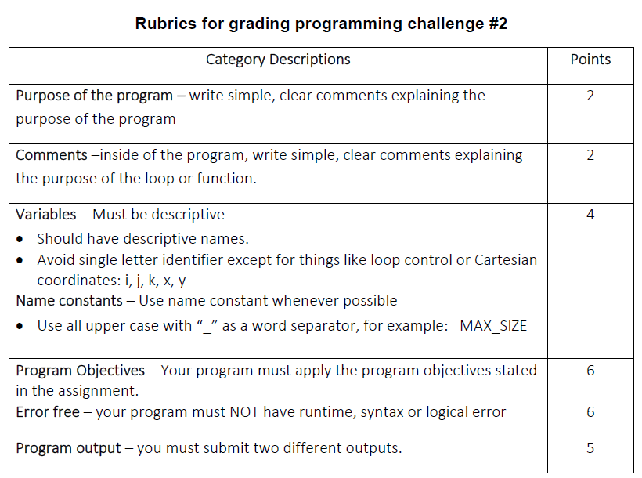

**Copy and paste your program (source) code and the outputs after this line**

**+++++++++++++++++++++++++++++++++++++++++++++++++++++++++++++++++++++++++++++**